I Spy—Summary
Class: ______ No.: ______ Name: __________________ 1090907
- The information you need to search:
1. Is Yoon-Hee a spy? Why?
2. What mistakes does Edgar make?

- Summary of I Spy
It is the first day of Edgar’s new job as a spy. Edgar is in _________________. He wants to sell secret plans to a spy from another country, a woman. They plan to meet ______________ to the White House to exchange bags, but Edgar gets on the wrong bus and secretly exchanges bags with Yoon-Hee, a student who fits the other spy’s description. Edgar realizes his mistake when he opens Yoon-Hee’s bag and finds only ___________. The other spy sees the mistake and tells Edgar what happened. Edgar steals _______________ and chases Yoon-Hee. During the chase, Edgar has a couple of accidents: he almost hits somebody’s ______________, and then knocks _______________ out of another woman’s hand. These people, and the owner of the bicycle, chase Edgar. Edgar finally catches Yoon-Hee and tries to take his bag back, but it bursts open and the secret papers go everywhere. The three people chasing Edgar arrive at the same time, and they all jump on him. Yoon-Hee and her friend Kerry tell the police, and Edgar is arrested.
(A) an ice cream | (B) an apple
(C) dogs | (D) a bicycle
(E) on the bus | (F) Washington, D. C
- Find the sentences in the book:
1. 祈使句
- page ______ line from the top: ______ ________________________________________________________________________
- page ______ line from the top: ______ ________________________________________________________________________
2. 現在式
- page ______ line from the top: ______ ________________________________________________________________________
- page ______ line from the top: ______ ________________________________________________________________________
3. 未來式
- page ______ line from the top: ______ ________________________________________________________________________
- page ______ line from the top: ______ ________________________________________________________________________
4. V1 ＋ to V2R
- page ______ line from the top: ______ ________________________________________________________________________
- page ______ line from the top: ______ ________________________________________________________________________
5. 感官動詞
- page ______ line from the top: ______ ________________________________________________________________________
- page ______ line from the top: ______ ________________________________________________________________________
I Spy—Oral Test
Class: ______ No.: ______ Name: __________________ 1090915
- Sentence Pattern / Key Words
- 程序：first, next, then…last
- 花費：cost, spend, take
- 交通：by / in / on…, take, ride, walk…
- Template
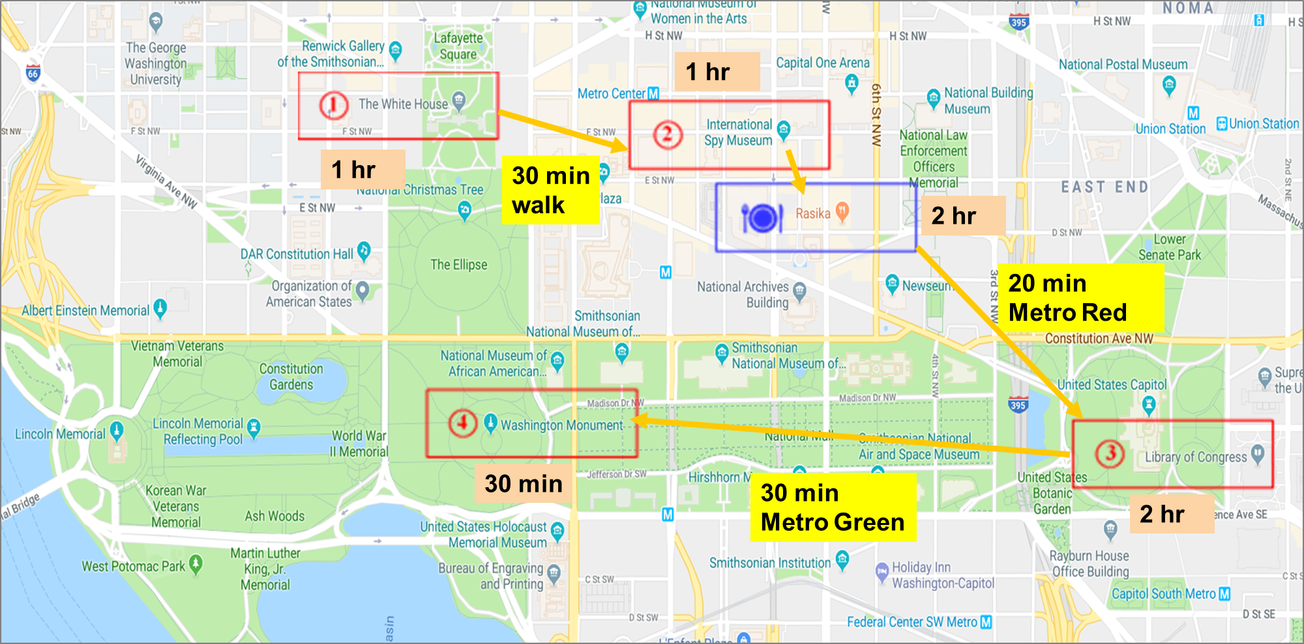
- This is my plan of one-day tour in Washington DC. I plan to visit four places and eat lunch at an Indian restaurant. First, I’ll spend one hour at the White House, and then spend thirty minutes walking to the Spy Museum. I’ll stay in the museum for one hour. Later, I’ll eat lunch at Rasika. People say the food is very delicious, so I’ll spend two hours enjoying the meal. After lunch, I’ll go to Library of Congress by Metro. It takes twenty minutes for a ride. I’ll spend two hours taking a look at it. At last, I’ll take the Metro again for thirty minutes to Washington Monument. I’ll spend only thirty minutes there.
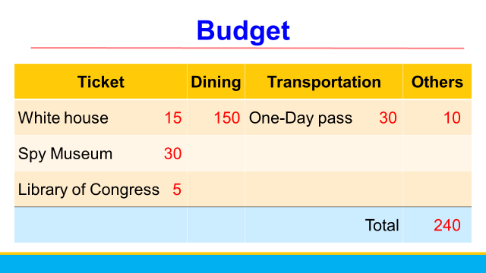
- This is my budget. The whole tour costs me two hundred forty dollars.
The Draft

I Spy-- Summary Class: No.: Name:
The information you need to search:
1. Is Yoon-Hee a spy?
No, she is a student.
2. What mistakes does Edgar make?
He meets the wrong person and takes the wrong bag.
He steals a bicycle. During the chase,
He almost hits somebody’s dogs.
He knocks an ice cream out of another woman’s hand.

Summary of I Spy
It is the first day of Edgar’s new job as a spy. Edgar is in (F) Washington, D. C. He wants to sell secret plans to a spy from another country, a woman. They plan to meet (E) on the bus to the White House to exchange bags, but Edgar gets on the wrong bus and secretly exchanges bags with Yoon-Hee, a student who fits the other spy’s description. Edgar realizes his mistake when he opens Yoon-Hee’s bag and finds only (B) an apple. The other spy sees the mistake and tells Edgar what happened. Edgar steals (D) a bicycle and chases Yoon-Hee. During the chase, Edgar has a couple of accidents: he almost hits somebody’s (C) dogs, and then knocks
(A) an ice cream out of another woman’s hand. These people, and the owner of the bicycle, chase Edgar. Edgar finally catches Yoon-Hee and tries to take his bag back, but it bursts open and the secret papers go everywhere. The three people chasing Edgar arrive at the same time, and they all jump on him. Yoon-Hee and her friend Kerry tell the police, and Edgar is arrested.
(A) an ice cream | (B) an apple
(C) dogs | (D) a bicycle
(E) on the bus | (F) Washington, D. C

