02 Booking a room. Members: 108.07.08
Place to visit: Brisbane City Hall
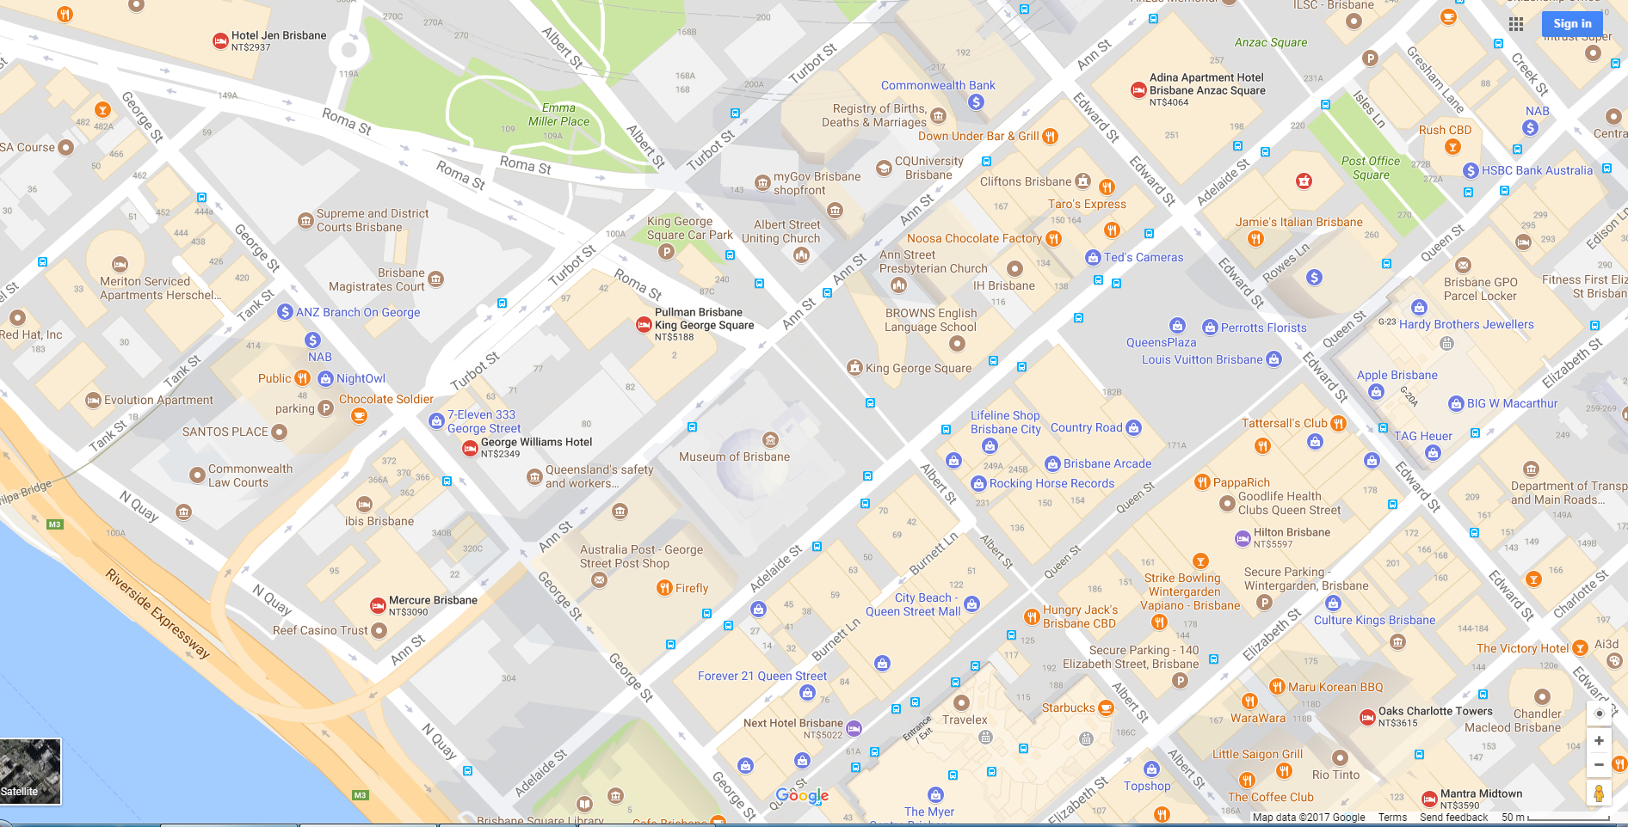
Hotels you can choose nearby:
8
6
5
7
4
3
2
1
City Hall
Pullman Brisbane King George Square:
https://goo.gl/cpym2e
George Williams Hotel
https://goo.gl/YxDB4E
Hotel Jen Brisbane
https://goo.gl/LKfWwG
Adina Apartment Hotel
https://goo.gl/upW3p7
Hilton Brisbane
https://goo.gl/B4bfPJ
Oaks Charlotte Towers
https://goo.gl/R82GHe
Mantra Midtown
https://goo.gl/ehPDSY
City Edge Brisbane Hotel
https://goo.gl/QW9LBJ

Please choose the rooms from two of the hotels and tell us why you choose it:
Items | Hotel A: | Hotel B:
distance from City Hall
price
size of the room
convenience
comfort
Facilities / equipment

